STAT301 Worksheet 6 Name Charles Sandahl
- We would like to study the effect of pizza consumption and the timing of eating pizza on mood. The study recruited 16 volunteers, and randomly assigned 8 of them to eat Pop Johns’ Pizza, and the other 8 eat Domino’s Pizza. All 16 volunteers had Pizza for both breakfast and dinner. The researchers recorded their mood scores 3 hours after they had Pizza. The higher score, the happier mood. The data is provided in the table below. Use the 0.05 significance level.
Perform an appropriate analysis to test the main effect of the type of Pizza, the main effect of timing, and the interaction between type of Pizza and timing.
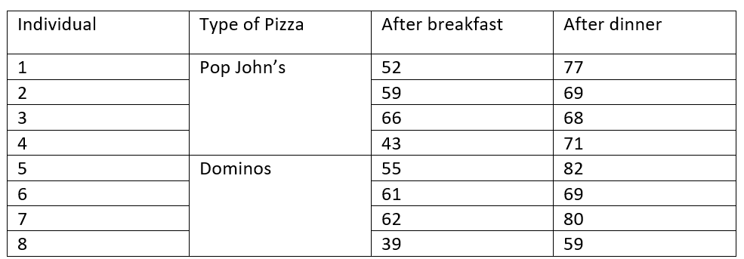
- What are the F statistic and p-value for testing the main effect of type of Pizza?
$$F-Value=0.0142$$
$$p-value=0.9089$$

- What conclusion can you make about the main effect of Pizza?
The p-value is 0.9089, which is significantly higher than our 𝛼-value of 0.05, so we fail to reject the null hypothesis which suggests that there is no evidence that the timing of the meal influences the mood score.

- What are the F statistic and p-value for testing the main effect of timing/meal?
$$F-Value=22.2650$$
$$p-value=0.0033$$

- What conclusion can you make about the main effect of timing/meal?
The p-value is 0.0033, which is significantly lower than our 𝛼-value of 0.05, so we reject the null hypothesis which suggests that there is evidence that there is a significant difference of mood scores for timing.

- What is the p-value for the interaction term? What conclusion can you make about the interaction?
$$F-Value=0.0748$$
$$p-value=0.7936$$
The p-value is 0.9089, which is significantly higher than our 𝛼-value of 0.05, so we fail to reject the null hypothesis which suggests that there is no evidence that the timing of the meal interacting with the type of pizza has a significant effect on the mood score.

- Does physical exercise alleviate depression? We find some depressed people and check that they are all equivalently depressed to begin with. Then we allocate each person randomly to one of the three groups: no exercise; 20 minutes of jogging per day; or 60 minutes of jogging per day. At the end of a month, we ask each participant to rate how depressed they feel on a Likert scale from 1 (totally miserable) through 100 (ecstatically happy). Here is the data. Use 0.05 significance level to test the claim that the depression level (score) is significantly different between the three exercise groups.
Step 1: State the null and alternative hypotheses
$$H_{0}: μ_{noExercise} = μ_{20MinExercise}= μ_{60MinExercise}$$
$$H_{a}:At least two medians are different$$
Step 2: What test would you choose?
Kruskal-Wallis
Step 3: What is the test statistic and p-value?
Kruskal-Wallis chi-squared = 8.34, p-value = 0.01545
Step 4: What is your decision?
The p-value is 0.01545, which is significantly lower than our 𝛼-value of 0.05, so we reject the null hypothesis which suggests that there is evidence that depression score median is significantly different between exercise groups.

Step 5: What can you conclude from the post-hoc (follow up) test?
20-minute exercise and 60-minute exercise have a significant difference with a p-value of 0.0317 and a significant difference between 60-minute exercise and no exercise with a p-value of 0.0079.

